Haiku writing
Plan and Guidance Notes
Outcomes:
Children have:
- A greater understanding of the Haiku form
- Written their own haiku based on a subject of their choice.
Suggested route
- Issue children with exemplar haikus on spring or summer. Ask them to identify the form of a haiku. Prompt them to think about lines and syllables.
Haikus will always have three lines. There are always five syllables in the first and last lines, and seven syllables in the second. Haikus often have a natural theme.
- Complete a spider diagram of the different things happening on the farm/ in the natural world in spring. E.g. leaves appear on trees, daffodils bloom.
- Use the spider diagram as an idea-bank to create a haiku.
- Write haikus in boxes provided, then Illustrate haikus in boxes beside them.
- Use the haiku success criteria to self-assess. Encourage children to evaluate their work carefully. If at this point they identify a mistake, e.g. with number of syllables, encourage them to redraft.
- Should your child enjoy the process, why not ask them to write one haiku for each of the four seasons? The work could then be illustrated to display in the home or shown to teachers.


Haiku
Look carefully at the examples of haiku poetry on this sheet. They are all about spring and summer, but what else do you notice about each one? Based on these examples, what do you think are the ingredients for a haiku?
Summer
Cows graze in the sun
Farmers cut hay from the fields
Lambs shade beneath trees
Summer
Flowers are in bloom
Colour bursts from the garden
Watering cans busy
Summer
Blue water shimmers
Lazy waves stroke yellow sand
Children splash and shriek
HAIKU
Spring
Spring is really here.
Flowers are starting to bloom.
Sunshine fills the air.
Spring
Spring finally came
New life is all around us
Lambs leap in the fields
Summer
Sea so blue and clear
Birds are chirping merrily
Shells gleam in the sun.

Tip Box
Read the poem out loud. Use your fingers to count the numbers of syllables in each line as you read.
Clarification Corner: Syllable

A syllable is one beat in a word.

For example:
The word ‘red’ has one syllable because it only has one beat.
Orange has two syllables because it has two beats: or+ange
Flower also has two syllables: flow+er
Syllable has three syllables: syll+a+ble

Ingredient

Content/ theme | Haikus are usually about the seasons, nature, or the weather.

Task: Think about what you can see, hear and touch in nature or on the farm? What do you think you could smell or taste?

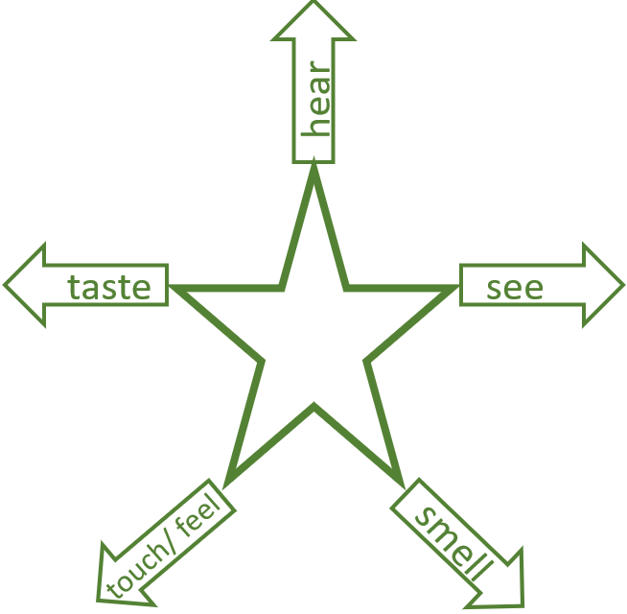

Tip Box
Don’t forget that when you make notes, you don’t always have to write in full sentences. Sometimes, you only need key words that will refresh your memory later.
Don’t worry if you run out of space next to one of your arrows, just write your notes somewhere else on the page.
My Haiku

……………………..

………………………………………………………………………………………………………………………………………………………………………………………………………

……………………..

………………………………………………………………………………………………………………………………………………………………………………………………………

……………………..

………………………………………………………………………………………………………………………………………………………………………………………………………

Success Criteria for Haiku

 | Criteria | What I think | What others think
 | My haiku has three lines
 | My haiku has five syllables in the first line
 | My haiku has seven syllables in the second line
 | My haiku has five syllables in the third line.
 | My haiku is about a natural subject
 | I have used a range of interesting vocabulary choices.
 | I have used sensory details.

