
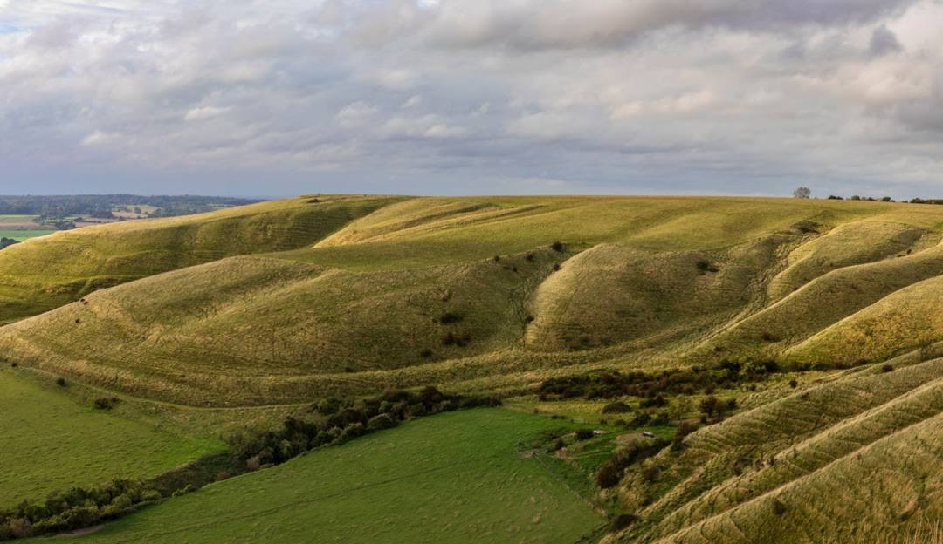
The Brown family has been farming in the village of Aldbourne on the rolling Marlborough Downs for six generations. Sheep have been farmed on this beautiful chalk downland since the Middle Ages, first for their wool, then their meat, and now on this farm for their milk.

The farm started to diversify into sheep milk five years ago, encouraged by the belief in this highly nutritious product and by the ethical credentials of producing sheep milk. The sheep graze around the farm most of the year, except when the weather gets bad in the winter, when they are brought in to spacious open sheds for shelter and extra rations of home-produced forage. We are integrating pasture in to old tired arable land as part of a mixed farming system. We aim to minimise all synthetic inputs, with an emphasis on biological methods to improve the health of our soil, our sheep, and ultimately ourselves.

Sheep flock: Shellswood Dairy has about 450 dairy sheep which lamb in the autumn months. On the farm are also the young lambs, and the ewe lambs from the previous year waiting to be introduced into the flock. The main breeds are Freisland and Lacaune, with other breeds such as Dorset being introduced through a selective breeding programme. Each breed brings different attributes and behaviours which adds a great deal of character to the flock.

Ewe health is considered to be as important as productivity; the modern parlour records the production of each ewe, but the next generation of milkers is also being selected on traits such as temperament, conformation and health. The welfare of the sheep is a top priority and is monitored daily either through the parlour or in out in the pastures.

The ewes are lambed either indoors or outdoors depending on the weather conditions, and the lambs are kept with their mothers for a month, before being weaned onto quality grass. This system of allowing the ewes to raise their own lambs gives the lambs a good start in life, is low in stress for the ewes and the farmer!

Sheep milk: As well as being extremely tasty, there are great health benefits to sheep milk

- A2 milk - the A1 milk versus A2 milk discussion relates to the type of beta casein proteins contained in the milk of a dairy animal, particularly as it relates to cow breeds. A2 beta casein is better tolerated by some people otherwise sensitive to A1 beta casein. All sheep breeds are A2, thus all sheep milk is A2.
- Naturally homogenised - this means that the fat molecules are small enough to stay suspended in the milk, which makes for an easier digestive experience for some people and gives it a creamy consistency.
- Early research shows that sheep’s milk can be digested in 45 minutes; cow’s milk can take well over 2 hours; this is of benefit not only to people with milk intolerances, but also to athletes looking for rapid absorption of nutrients post exercise, or those looking for a perfect nightcap.

Sustainability is very important for us, part of the reason for dairy sheep is their low nitrogen leaching risk compared to cows, very important on our sensitive chalk downland.
Welcome to Shellswood Dairy

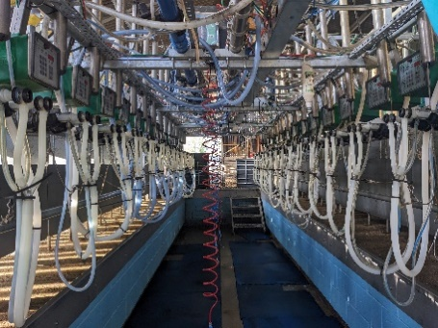

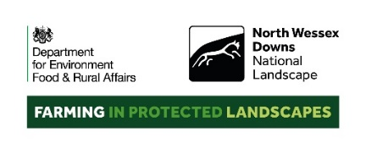
After an introduction to Shellswood Dairy and a health and safety briefing…
Sheep breeds and characteristics: Using photos and information on each of the key sheep breeds at the farm, students identify which sheep they believe are predominantly Freisland, Lacaune and Dorsets. What are the characteristics of each breed, how have they benefitted the flock in terms of health, resilience to disease and worm burdens, longevity, productivity – both in terms of lambs born but also in terms of milk given.
Health check activity: Students pretend to be Judges at a Sheep Show, and must review a variety of sheep which have been conveniently placed in pens. Students must identify their breed, age and gender, as well as give them a condition score and consider their feet, udders and overall health. Students are asked to rate them and advise which they would recommend for breeding, either as a dairy ewe or for meat. Why are they different, what does this mean for the Farmer?
Tour of the farm and milking parlour: considering the RSPCA five freedoms, students are asked to find as many examples as they can:
- Freedom from hunger or thirst by ready access to fresh water and a diet to maintain full health and vigour.
- Freedom from discomfort by providing an appropriate environment including shelter and a comfortable resting area.
- Freedom from pain, injury, or disease by prevention or rapid diagnosis and treatment.
- Freedom to express normal behaviour by providing sufficient space, proper facilities, and company of the animal's own kind.
- Freedom from fear and distress by ensuring conditions and treatment that avoid mental suffering

Grassland management activity: a large part of the sheep’s diet is the grass grown in nearby fields. Students explore the fields, and identify what is growing there using sampling techniques to collect data. Students assess the role of grassland legumes in the nitrogen cycle and how that has enabled Shellswood Dairy to reduce the use of artificial fertiliser on the farm and understand how diversity of plant species can benefit agricultural livestock and the environment - Grassland Resource Pack | Teaching Resources | Countryside Classroom

Comparison of sheep and cow milking processes and products: To understand what the students have learnt on their visit to the farm, they are asked to answer a series of questions using true and false cards. Sampling of cheese and yoghurt produced by cows, goats and sheep helps them to really appreciate the differences in products.
Sheep milking at Shellswood Dairy

