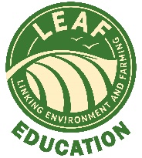
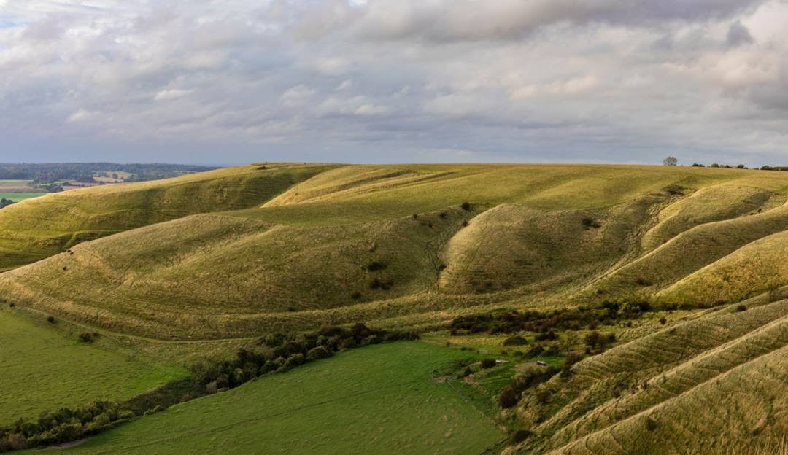
Field Barn farm is a 1000-acre family run farm with sheep, cattle and horses, there are a range of rare breed sheep and cattle that are all cared for and butchered onsite to provide beautifully fresh grass-fed meat to the local community.

Beenham Park Herefords
Field Barn farm cares deeply about their herd of native, rare-breed cattle, naturally raised and bred here in Beenham Village for 3 generations.
Food preparation
In addition to providing meat, our onsite experts can advise on how to make healthy nutritious recipes, not only using the finest cuts of meat, but also how to reduce waste by demonstrating tasty recipes using offal at the onsite farm kitchen and classroom.
School groups can have the whole farm to fork experience by having butchery demonstrations, also by preparing and cooking food produced on the farm in the onsite farm kitchen.

As well as all of our tasty beef, we have something for your furry friend too. Our raw beef bones are the perfect natural long-lasting chew. All bones should be given under supervision and any loose pieces of bone removed before giving.

Welcome to Field BarnFarm

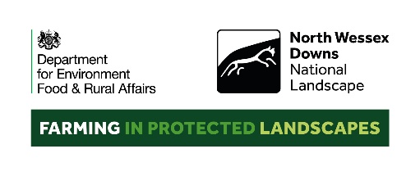
Farmer Kate Bowsher delivers a fantastic farm to fork workshop which is perfect for a half day or full day visit for food preparation and nutrition or Environmental Management students or for any group wanting to know more about how to reduce food waste. Mixed farms like Field Barn Farm use integrated farm management to reduce artificial inputs being used and help to tackle climate change.
Groups begin with a walking tour of the farm; this is possible because the fields are only a short walk away from the farmyard which has ample car parking. Visitors can see how Kate’s herd of rare breed cattle and sheep are reared in harmony with the environment. Students can learn about how herbal leys are being sown into the pasture to not only benefit the soil and its microorganisms but how the various herbal plant varieties benefit the health of the animals as well as reduce the need for worming products to be used.
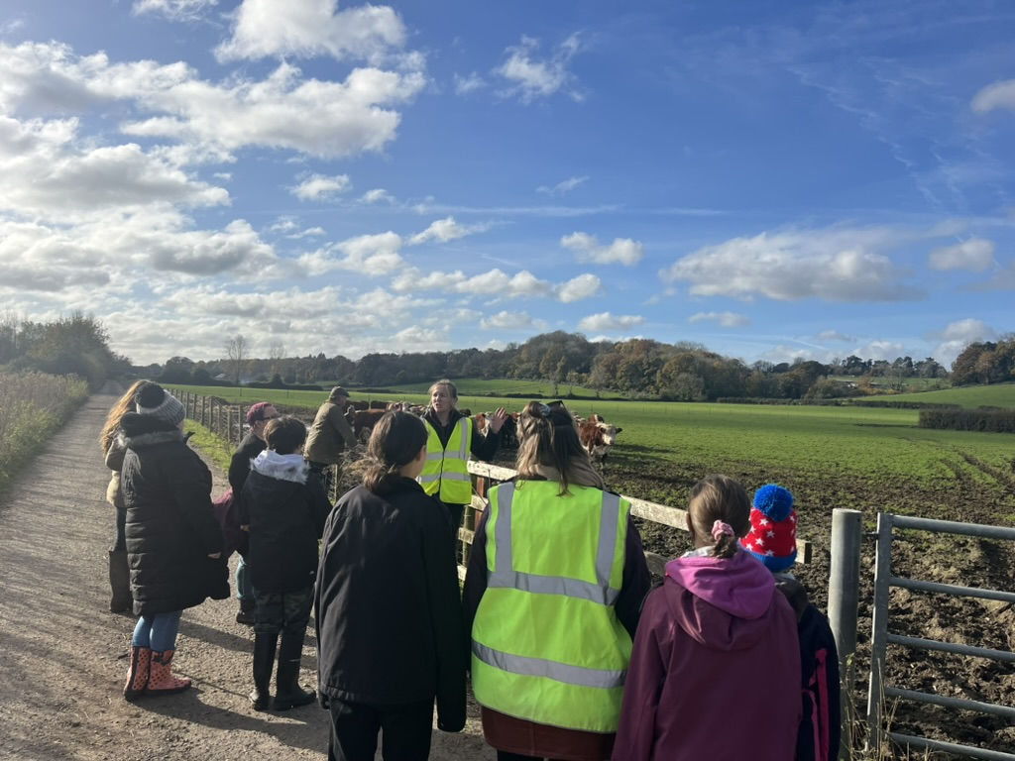
Children then can visit the farm shop and onsite classroom to see and learn about all the different cuts of meat, what they are called and the nutritional value of each cut and the associated cooking methods recommended for each part of the animal and the science behind why they differ.
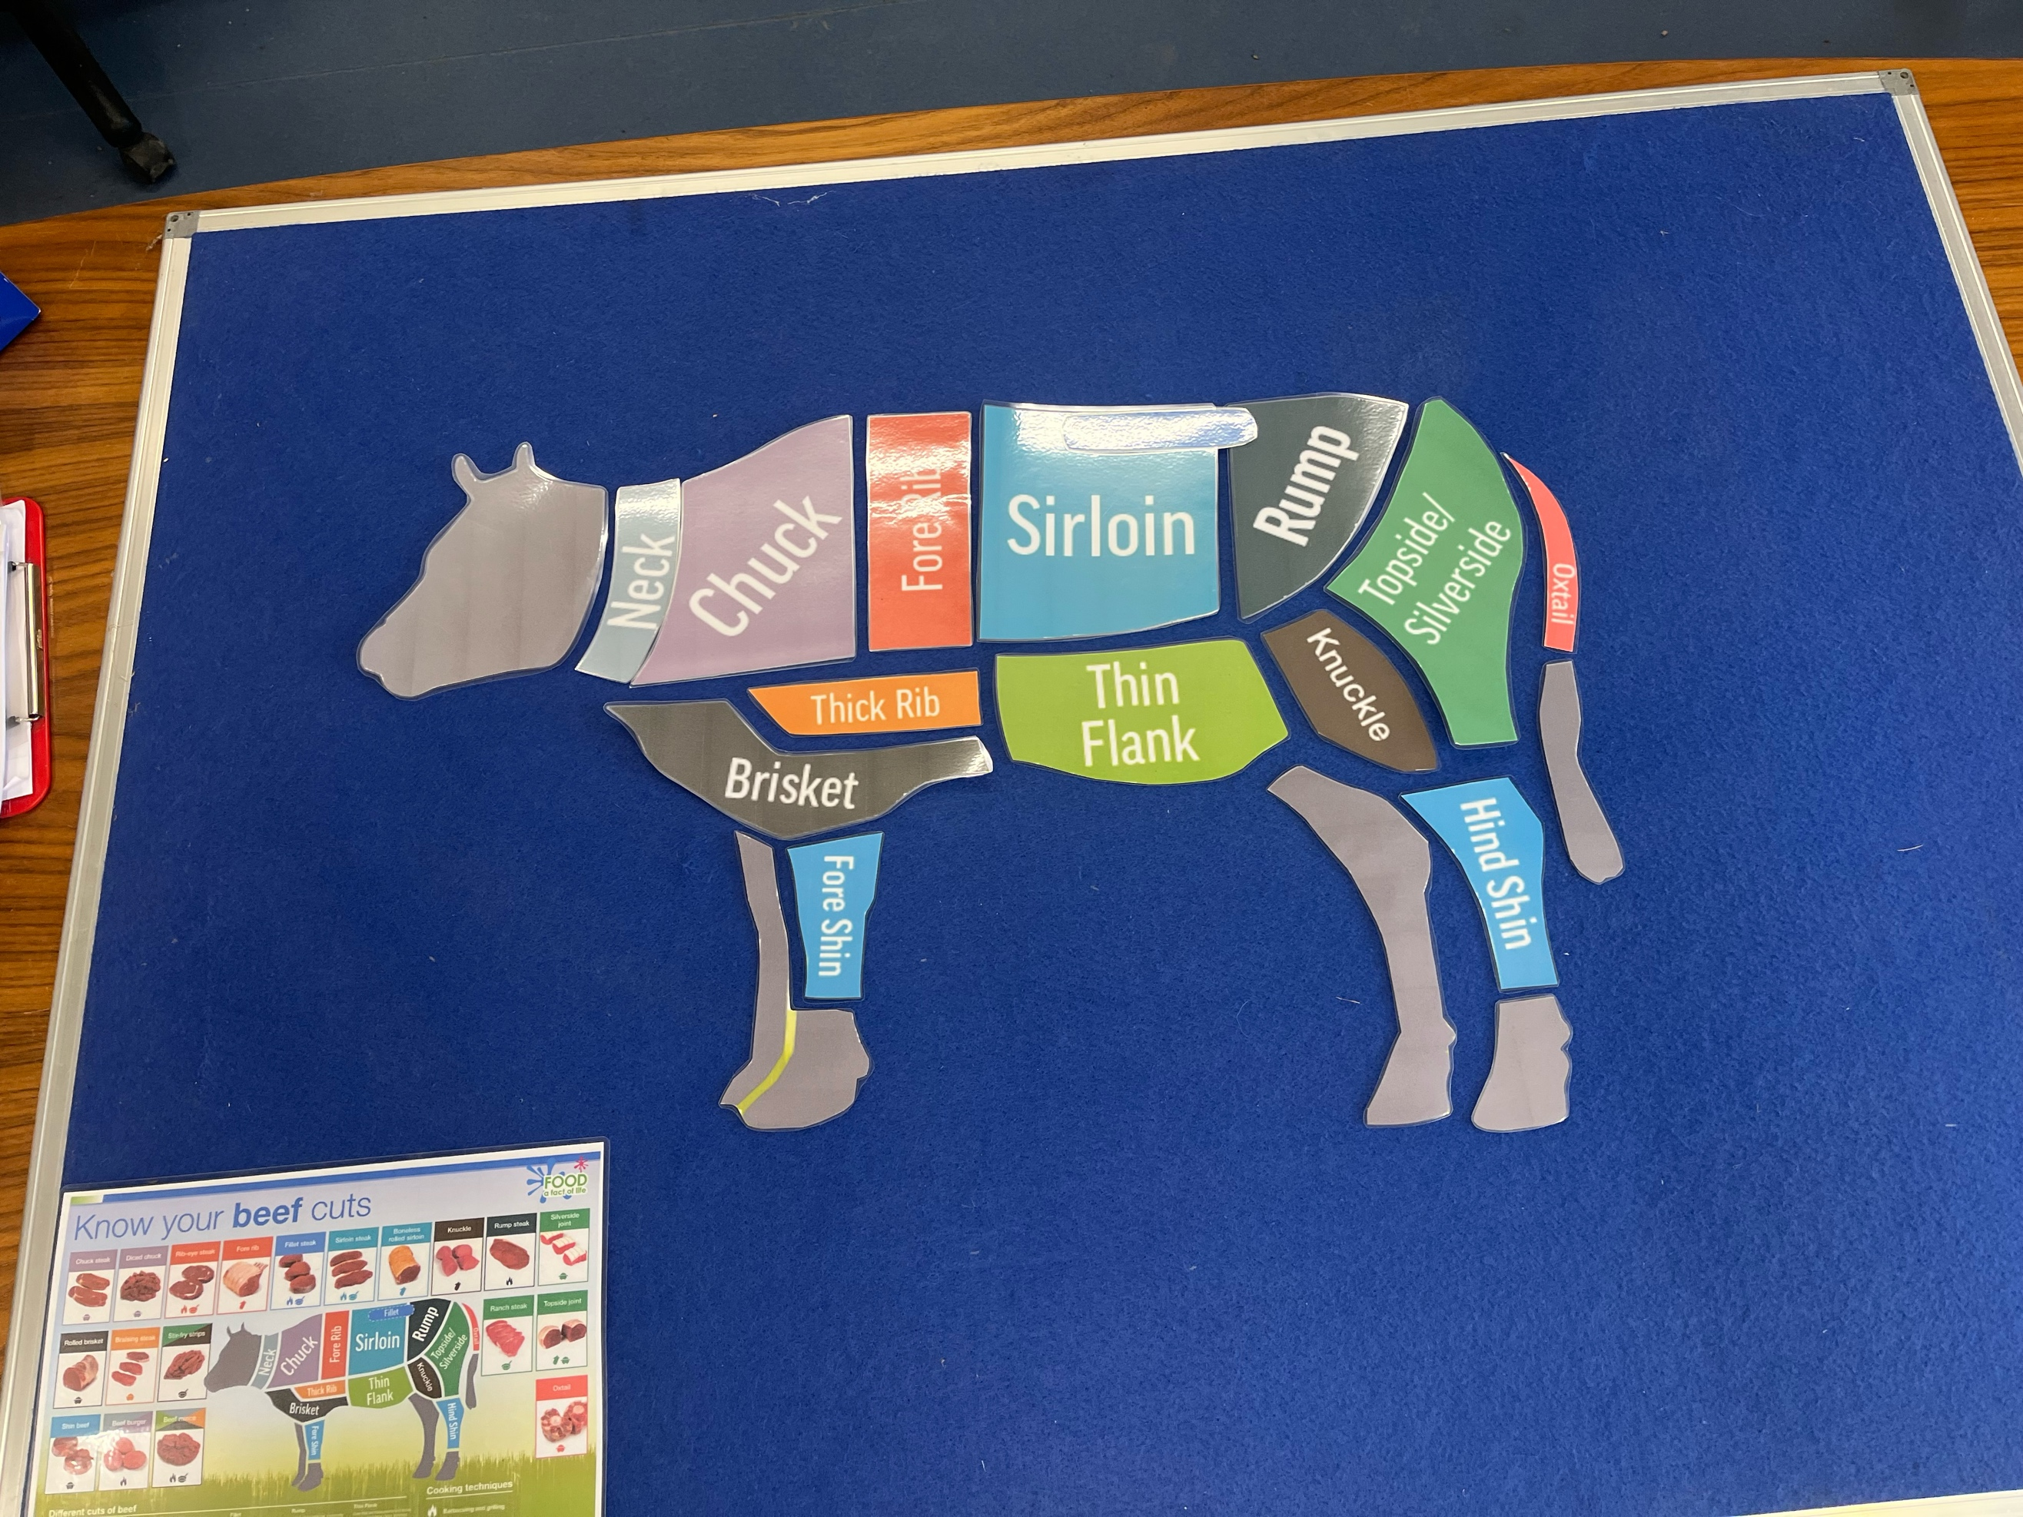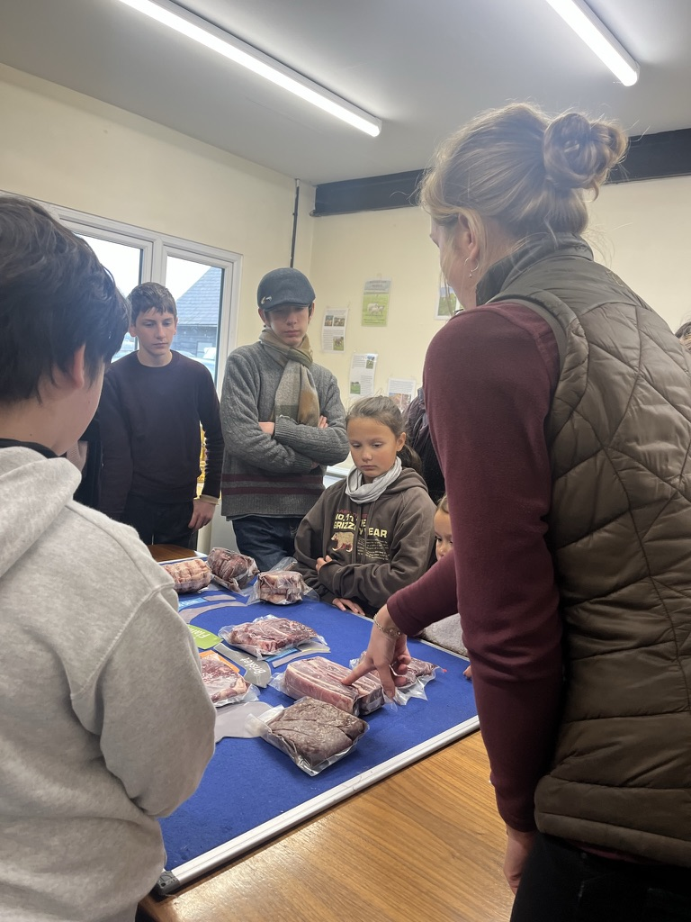
Food Preparation & Nutrition
at Field Barn Farm

